Greetings,
I'm the founder and General Manager of Mioty Voajanahary, the company producing Alomac in Madagascar. Alomac is made from the gel of Aloe macroclada, a type of aloe new to most of the world, yet well-known in Madagascar. After demonstrating Aloe macroclada gel increased circulating stem cells better than any other natural product, and was completely safe, I decided the world needed a supply of Aloe macroclada gel.
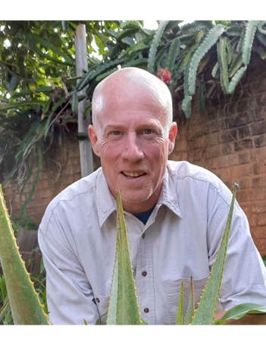
Several years later, Alomac is in multiple products and gaining attention. We have become experts at cultivating Aloe macroclada plants from seeds to mature plants. We also plant many trees and implement water conservation practices to minimize erosion and maximize groundwater retention. Our business benefits many Malagasy while making humble efforts to restore the flora and fauna.
Alomac is a better aloe, containing an average percent polysaccharides higher than all other commercial aloes of over 25%. Efforts are underway to characterize these polysaccharides, some of which are acemannans.
I plan to tell Alomac's story on this site, one blog post at a time. It's a great story which I'm proud to share. Alomac is the better aloe from Madagascar.
Best regards,
John James

