Stem Cell Research
Alomac® - Dried Aloe macroclada gel (vahona)
http://alomac.com/research
Alomac is a unique aloe, found only in Madagascar, and shown to upregulate the stem cells in the body better than any other natural product and without the toxicity of unnatural products.

Drapeau, C, Benson, K.F, James. J, and Jensen, G.S. (2015) Aloe macroclada from Madagascar Triggers Transient Bone Marrow Stem Cell Mobilization, Journal of Stem Cell Research & Therapy, 5:6, DOI: 10.4172/2157-7633.1000287

Objective: Aloe has been used for the treatments of various ailments dating back almost 6000 years. There are more than 450 species of aloe coming from various parts of Africa and South America, and from the island of Madagascar that contains unique species endemic to the island. One such species is Aloe macroclada that has been used for centuries by the local residents as a remedy for a wide variety of ailments. We investigated whether the mechanism of action behind the wide-ranging health benefits of A. macroclada could be mobilization of bone marrow stem cells.

Methods: A. macroclada was prepared into small spherical pellets by Malagasy healers using traditional methods of fabrication. The traditional dose of three pellets was fed to 4 volunteers and the number of circulating stem cells was quantified 1, 2 and 3 hours after consumption using flow-cytometry.

Results: The usual dose and preparation of A. macroclada traditionally used in Madagascar triggered a significant increase (up to 53%) in the number of circulating CD45dim CD34+ and CD34+ CD133+ stem cells within 2 hours of consumption. This increase lasted more than 3 hours and was significant after 120 and 180 minutes of consumption.

Conclusion: Consumption of A. macroclada has been credited with significant improvements in a wide variety of heath conditions. This data suggest that stem cell mobilization may be an important mechanism of action behind the health benefits of A. macroclada.

Following this positive study with healer-made pellets (calculated to contain 70-100mg A. macroclada gel), additional clinical studies were performed on the pure A. macroclada gel powder. Subjects were dosed at 250 and 750mg and samples were taken to monitor stem cell concentrations similarly to the first study. These studies have not yet been published, however some preliminary data is available at this time. The two following graphs show the average CD34+CD133 cell counts over time for each dose group and the maximum level with standard error of mean within the group.
John W. James, Owner and General Manager
Phone: +261 342771950 (Madagascar), +1 336 6553568 (US)
Email: john@alomac.com · Web: https://alomac.com

Overlay of Stem Cell Counts for Each Dose Group Average Maximum with SE Bars
John W. James, Owner and General Manager
Phone: +261 342771950 (Madagascar), +1 336 6553568 (US)
Email: john@alomac.com · Web: https://alomac.com
Christian Drapeau, et all
Publication pending

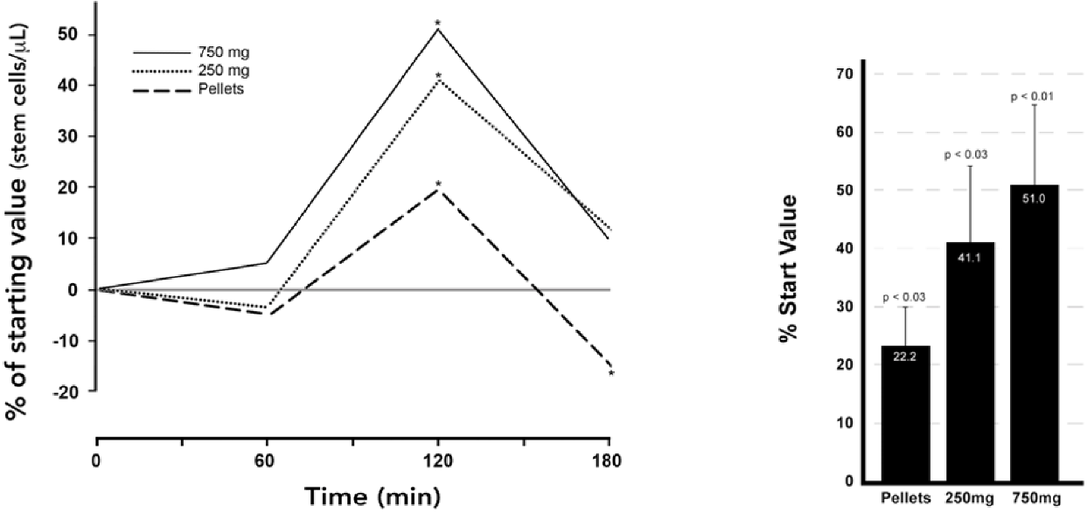

Compares data from pellets to Alomac powder from 2019 at 2 different concentrations
The percent change in circulating CD34+CD133 stem cells following consumption of A macroclada is shown as averages. The percent change compared to baseline stem cell numbers in the blood circulation was calculated from each of the study participants and then averaged.

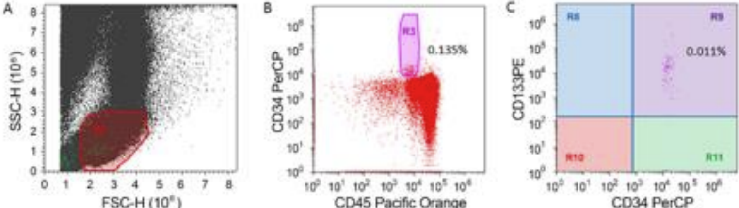

Flow Cytometry Analysis of Peripheral Blood
A. Representative profile of peripheral blood with respect to size (FSC) and granularity (SSC). The region defined by the electronic gate R1 excludes debris and contains cells with low granularity, including stem cells.
B. Dot plot showing the staining pattern for CD45 and CD34 for particles within the R1 region. The region defined by the electronic gate R3 contains the CD45dim C34+ stem cells.
C. Quadrant analysis of the R3 region showing fluorescence intensity for the stem cell markers CD34 and CD133, where the quadrant R9 contains CD34+CD133+ stem cells. The percentages shown are relative to the number of particles within region R1.

John W. James, Owner and General Manager
Phone: +261 342771950 (Madagascar), +1 336 6553568 (US)
Email: john@alomac.com · Web: https://alomac.com

